Query 1: Regarding the installation of kubernetes on aws ec2 instance.

Steps I follow :

Install docker from official web site of docker

Install k8s using kubeadm from official doc website my last step to install was- sudo apt-get install -y kubeadm=1.20.0-00 kubelet=1.20.0-00 kubectl=1.20.0-00

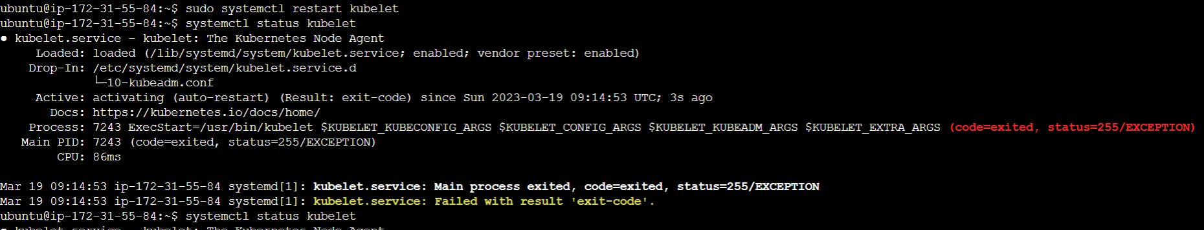On checking kubelet status error:

Query 2: I have setup the node mongo pod running both are runnig and node application running properly but how i confirm that node application connected to mongo db database .  
i have put the env in node js pod as:  
env:  
- name: mongo_url  
value: mongodb://mongo-service endpoint ip:27001/employee

Code I used to create resources

---

apiVersion: v1

kind: Service

metadata:

labels:

name: mongo

name: mongo

spec:

ports:

- port: 27017

targetPort: 27017

selector:

app: mongo

...

---

apiVersion: apps/v1

kind: Deployment

metadata:

name: mongo_deploy

spec:

replicas: 1

selector:

matchLabels:

app: mongo

template:

metadata:

name: mongo_pod

labels:

app: mongo

spec:

containers:

- name: mongo

image: mongo

ports:

- containerPort: 27001

volumeMounts:

- name: mongo

mountPath: /volume

volumes:

- name: mongo

emptyDir:

...

---

apiVersion: apps/v1

kind: Deployment

metadata:

name: nodejs

spec:

replicas: 1

selector:

matchLabels:

app: nodejs

template:

metadata:

labels:

app: nodejs

spec:

containers:

- name: nodejs

image: devopsedu/employee

ports:

- ContainerPort: 8888

...

---

apiVersion: v1

kind: Service

metadata:

name: nodejs

spec:

selector:

app: nodejs

type: Nodeport

ports:

- port: 8888

targetPort: 8000

nodePort: 30005

...

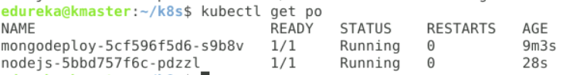

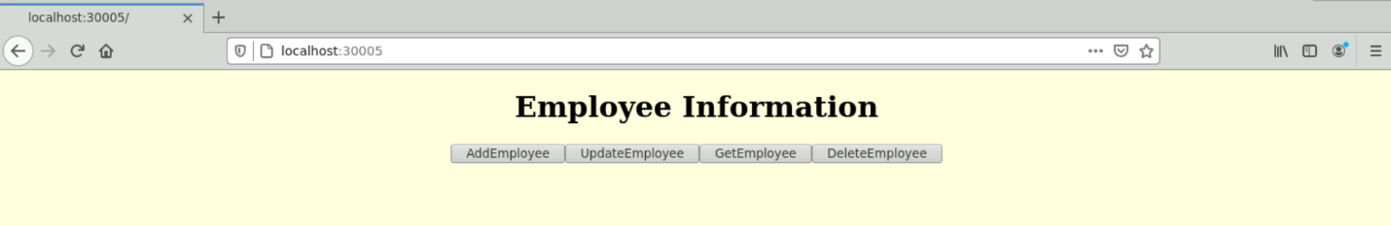

Query 3:

Setup Jenkins cicd pipeline for angular node project

It is my query not related to any assignment or project

On setting up pipe line I am unable to get how to run checkstyle and tslint command (step n0 6 from picture) on cheking the plugin in Jenkins shoe checkstyle deprecated

